WORKSHEET – 1.3

**Name :- Rahul maurya UID :-20BCS7260**

**Subject:- SE Lab class:- 716 B**

# Aim:

Development of DFD for the project.

**Task to be done:**

Draw a level 0 Data Flow Diagram (DFD) that fits the following system:

Students login with an email Id and password and the system provides access to the schedule for the current quarter. Students pick classes and enrol in them.

Enrolments are recorded in rosters. The system formats rosters for each class and sends them to teachers. Teachers can drop students on their rosters.

The DFD should have more than one process, more than one source/sink and more than one data store. The words in bold in the above box should appear in your diagram at least once. You may have to invent some names.

**Objective:**

The objective of Data Flow Diagram (DFD) is to graphically represent flow of data in an information system.

It is capable of depicting incoming data flow, outgoing data flow and stored data.

Training and Placement System is a software system that can store, update, and retrieve the information through Databases.

# Requirement Analysis:

## Software Requirement

Smart Draw Google Chrome.

## Hardware Requirement

Computer. Windows 10. Power Supply.

# Data Flow Diagram for Student Enrollment System:

Data flow diagram is graphical representation of flow of data in an information system. It is capable of depicting incoming data flow, outgoing data flow and stored data. The DFD does not mention anything about how data flows through the system.

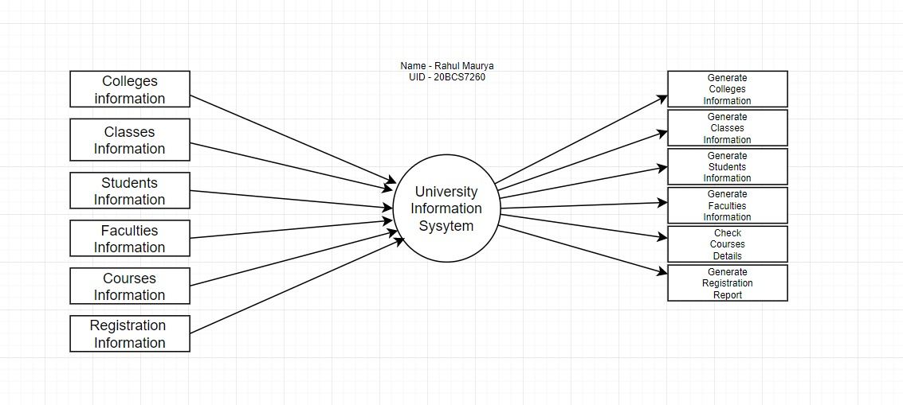

The University Information System Data Flow Diagram elaborates the context diagram into more detailed information to have a better vision

By looking into the designed illustration, you will know then the system’s broadened context terms. You just have to consider that the processes and data included in the illustration were based on the actual situation of University Management. In addition to that, this also serves as proof of how the inputs or data fed on the university management system were

handled. Then you will be also informed about the outputs that the system gives.

# Evaluation Grid (To be created as per the SOP and Assessment guidelines by the faculty):

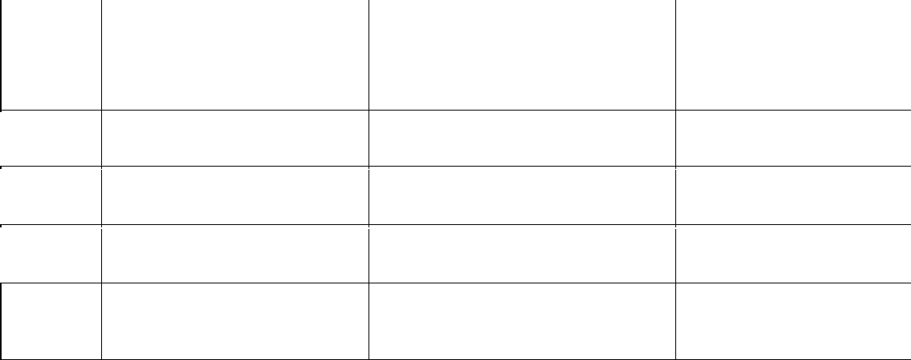

Sr.

No.

Parameters

Marks Obtained

Maximum Marks

1.

2.

3.